**STARAGILE DOCKER ASSIGNMENT -2**

**Step 1: Install Docker Compose**

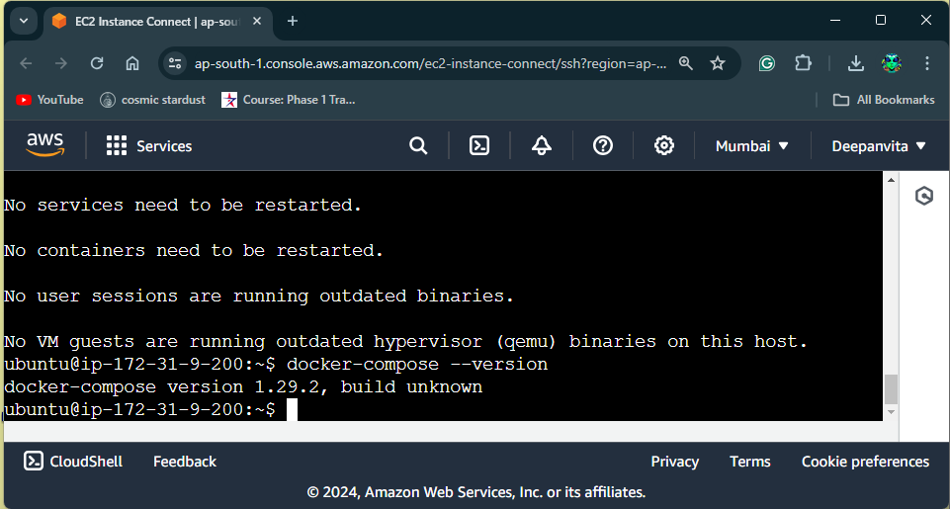

**Step 2: Create a Directory for Your Project**

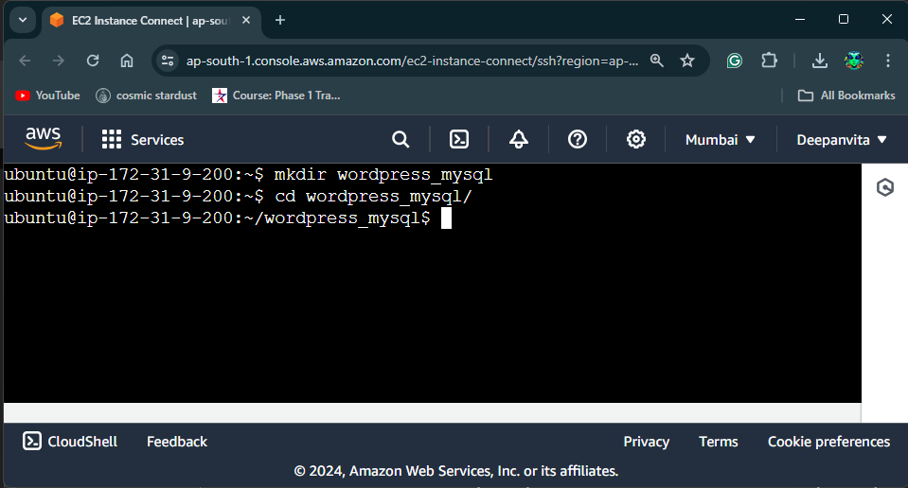

**Step 3: Create a Docker Compose File**

1. create a new file **docker-compose.yml**.

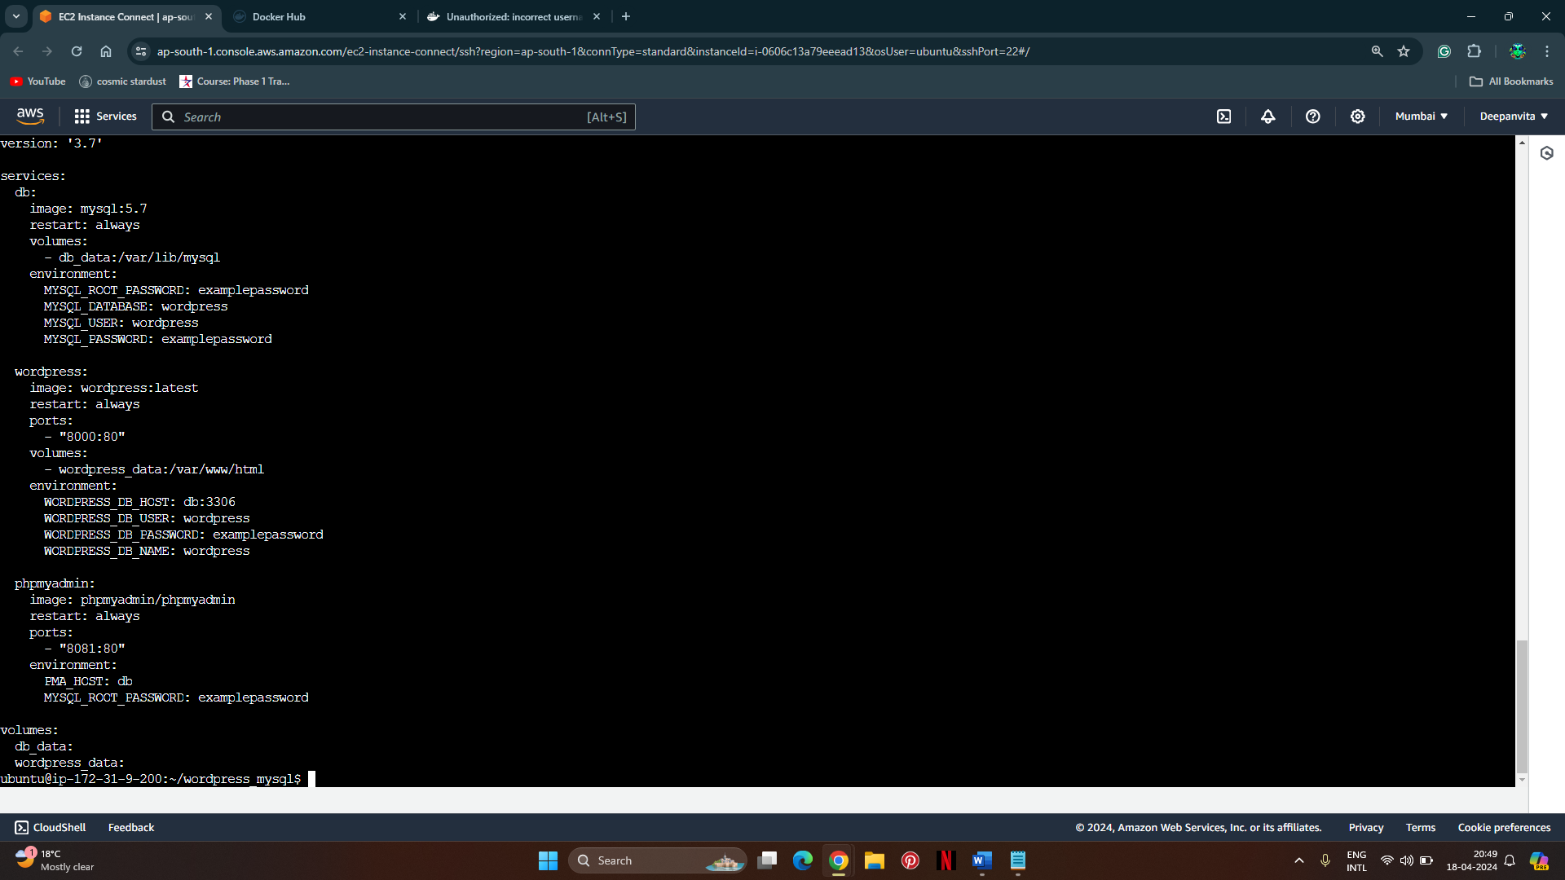

**Step 4: Write the Docker Compose Configuration (with Data Persistence)**



**Step 5: Save the File**

**Step 6: Run Docker Compose**

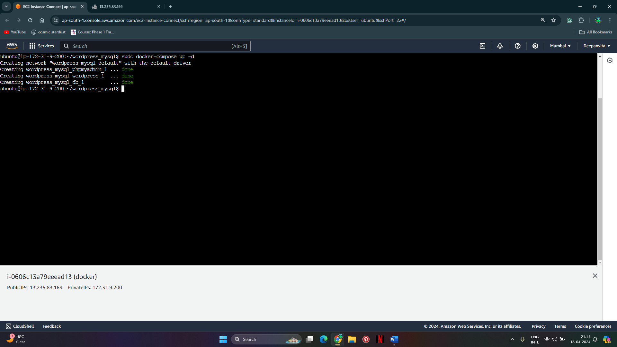

**Step 7: Verify WordPress Accessibility**

1. Open a web browser.
2. WordPress installation page, indicating that WordPress is accessible.

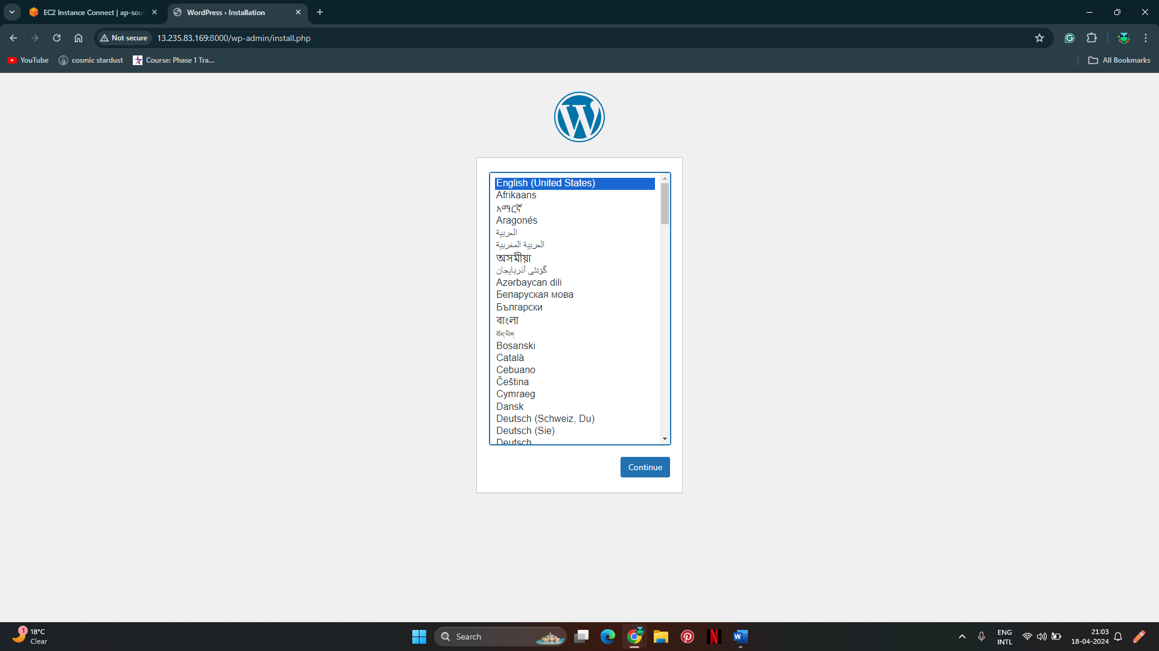

**Step 8: Access phpMyAdmin**

phpMyAdmin login page.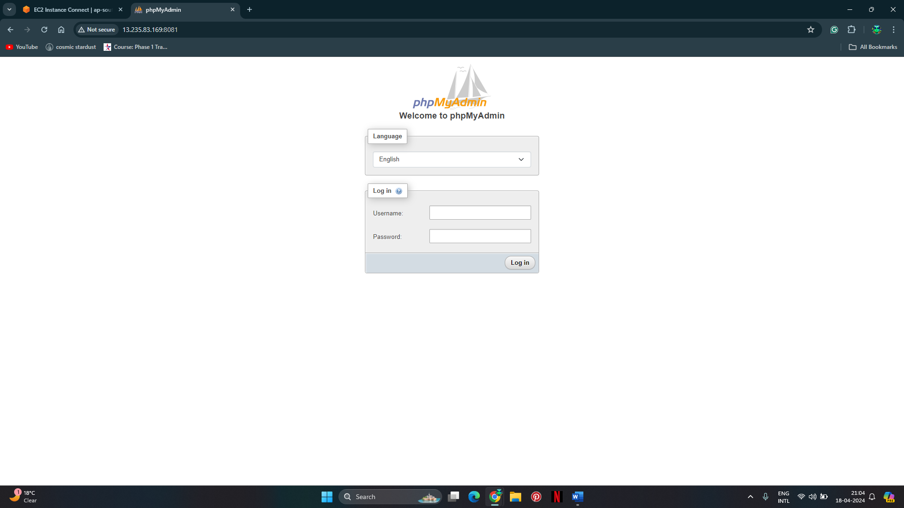

**Step 9: Verify MySQL Accessibility**

Log in with the credentials specified in the **docker-compose.yml** file.

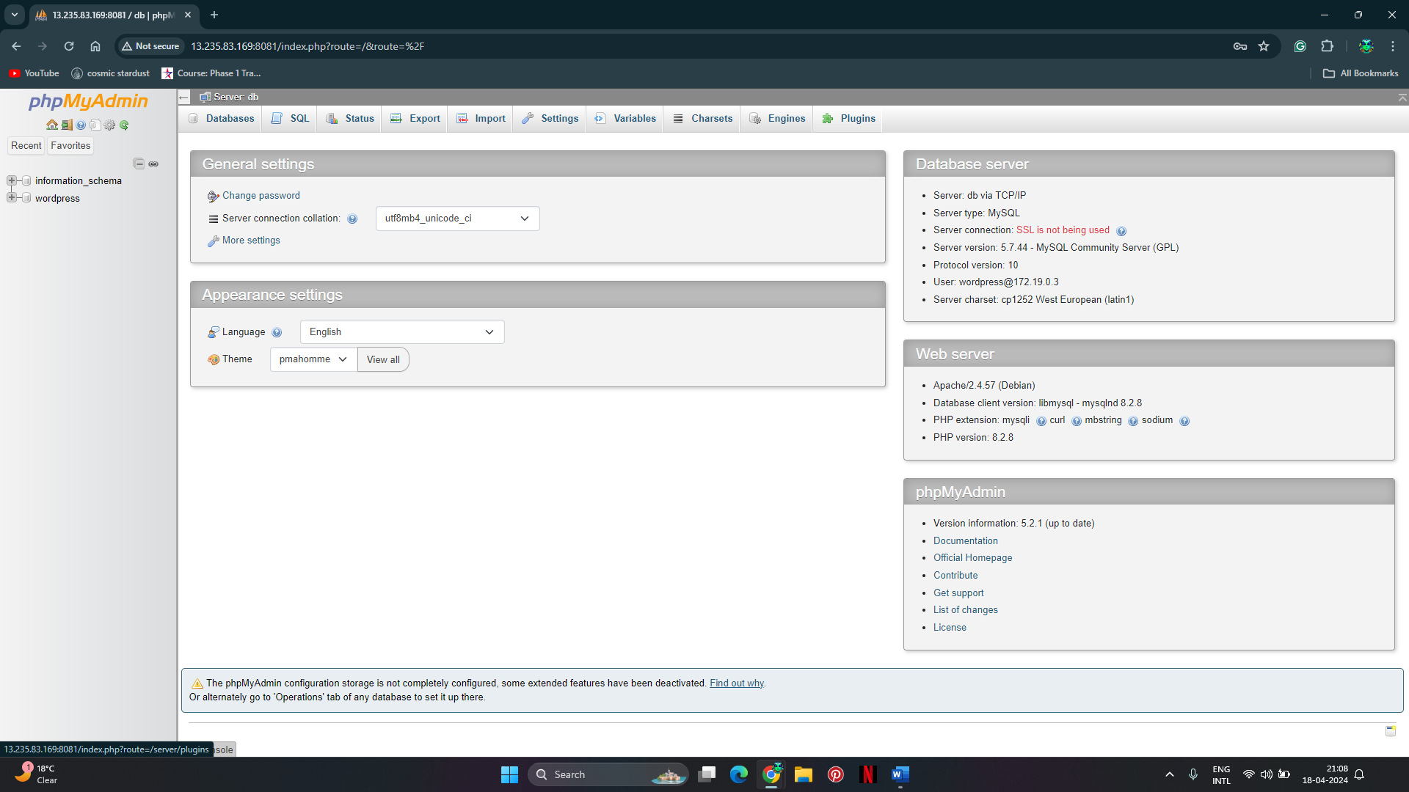

**Step 10: Stop Docker Containers**

